My Marble Jar
For each positive behavior you show in class that contributes to a marble in the class jar, you earn a sticker!
Once you fill up your entire jar you earn a prize!
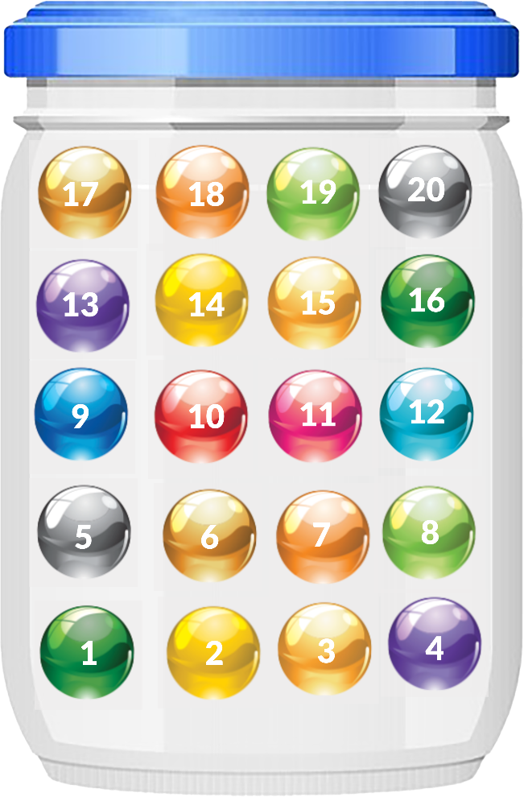
Name _______________________________________________________________________________

# | Your positive behavior | # | Your positive behavior | # | Your positive behavior | # | Your positive behavior
1 |  | 6 |  | 11 |  | 16
2 |  | 7 |  | 12 |  | 17
3 |  | 8 |  | 13 |  | 18
4 |  | 9 |  | 14 |  | 19
5 |  | 10 |  | 15 |  | 20

